**Lazy Evaluation**

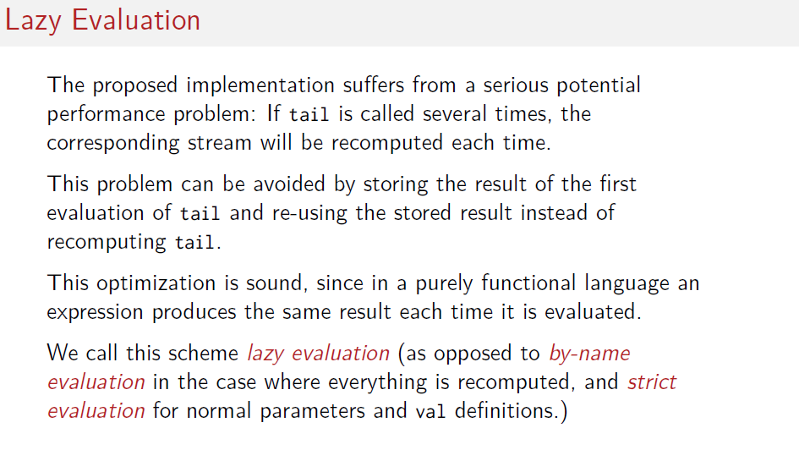**Lazy is evaluated only once when it is used.**

*val* x1 = 3  
val y1 = 3  
var number1=0  
lazy val operation1 = x1 + y1 + number1  
**println(operation1) --> (3+3+0)6 here lazy operation1 is been evaluated and used.**  
  
number1=4  
println(operation1)  
**println(operation1) --> (3+3+0)6 here lazy operation1 is been already. Hence it ignores the new value of** number1=4